Systematic Analysis of Proton Projectile Total Reaction/Interaction Cross-Section at Various Energies

**Lamessa Fekede Negero**

Department of Physics, College of Natural and Computational Science, Dambi Dollo University, Dambi Dollo, Oromia Region, Ethiopia.

**Authors E-Mail:** [**lamefeke@gmail.com**](mailto:lamefeke@gmail.com)

**Received** 2022 March 25; **Revised** 2022 April 28; **Accepted** 2022 May 15.

**Abstract**

The propagation and interaction of high-energy heavy ions in matter is a topic of great attention and action right now. We define the total reaction cross-section for nucleons incident on a nucleus as the total minus the elastic cross-sections: σR = σT − σel which is the most basic observable. The g-folding optical modal can be reproduced using a simple functional form with three parameters (lo, k, a). The heavy-ion total reaction cross-section is reproduced using same functional form, revealing that parameter lo behaves similarly to nuclear matter radii. The overall reaction cross section for proton-nucleus is computed as a function of the target nucleus' mass and neutron excess, as well as the proton incident energy. In this paper as the function of the mass and neutron excess of the target nucleus and the proton incident energy the total reaction cross-section is calculated for proton-nucleus. The interaction cross-section for neutron also calculated. Many types of nuclear reaction have been expressed and the total reaction cross-section is also determined for proton projectile at 65MeV and for interaction cross section at energy of 30, 60 and 200MeV. The result was compared with experimental data and gives a better agreement. The angular momentum dependence of nucleon function is the major reason to be mentioned.

Key words: reaction, cross-section, nucleus, protons, energy, heavy ions, neutrons

1. **Introduction**

Nuclear physics is the study of atomic nuclei. There are about 1700 natural species on the planet, ranging from deuteron to uranium [1]. Moreover, a vast number of others are generated in laboratories and within the interiors of stars. The main force responsible for nuclear characteristics is strong interaction. Weak and electromagnetic interactions, on the other hand, play crucial functions [2], [3]. For these reasons, nuclear physics is a crucial platform for investigating basic features of subatomic matter and studying fundamental physics rules. A nuclear reaction is defined in nuclear physics as the collision of two nuclei, or an atom's nucleus with a subatomic particle such as a neutron, proton or electron from external the atom, to yield one or more nuclides that are dissimilar from the nuclide(s) that begins the procedure[4], [5]. As a result, a nuclear reaction must convert at least one nuclide into another. Natural nuclear reactions occur when cosmic rays collide with matter, and nuclear reactions may be used artificially to generate nuclear energy on demand at a variable pace.

KE can be out through the reaction (exothermic reaction) or must be provided for the reaction to happen (endothermic reaction).

Q is the reaction energy which written on the right side of the reaction equation:

*Target nucleus* + *projectile → Final nucleus* + *ejectile* + *Q*

Exothermal reactions have a positive reaction energy (the Q-value), while endothermal reactions have negative reaction energy (the Q-value). It is the difference among the sums of kinetic energy on the final and starting sides on the one hand. We are usually interested in quantitative measures of the probability that a nuclear reaction or other collision process will occur while examining them [6]. This quantitative measure is always represented in terms of parameter of the cross-section. In nuclear physics, reaction cross-sections are important because they offer a measurement of nucleus size. They are useful for exposing unique nucleus properties such as stretched halo or neutron skins [7]. The strength of particle interactions is reflected in the scattering cross-sections and life-times of particles. Strong interaction is associated with big cross sections and short life durations, whereas weak interaction is associated with small cross sections and extended life spans. According to Zelalem et al [8], the overall reaction cross section (also known as reaction cross section) is critical in both statistical and optical model computations. For sufficiently high projectile energy, the reaction cross-section is proportional to the square of nuclear radius. As a result, it is a crucial measure in studies of matter distributions and nuclear size [9], [10]. Currently the interaction and propagation of high-energy heavy ions in matter is a hot topic of research. The total reaction cross-section minus the elastic cross-sections for nucleons projecting on a nucleus equal with the reaction cross-section is a fundamental observable:

*σR* = *σT − σel*

The basic structures of reaction cross-sections are required to understand nuclear strong interactions.

For more than 70 years [kox et al] [11], the total reaction cross-section has been both practically and theoretically explored intensively. When a nucleus receives enough energy, it will break up into slighter parts. This procedure is a key portion of the cross-section for high-energy proton-induced reactions. At projectile energy of 20 Mev per nucleon and greater, it can also be seen in heavy ion collisions. However, little theoretical work has been done on the breakup process in the vicinity of its threshold [12].

It’s familiar that reaction cross-sectional follows the *σR α A*2*/*3 relationship once the incident KE exceeds a certain threshold. Depending geometrical point of view, someone would imagine the total reaction cross-sectional *σR* for proton-nucleus reactions to be proportionate to the area perceived by the projectile, i.e., to *πR*2, where R is the nuclear radius, since R *α A*1*/*3. From this relation the reaction cross-section is sensitive to the size of the target. To be able to calculate the nucleon + nucleus and nucleus + nucleus total reaction cross-sections with precision is of nice importance for lessons of fundamental nuclear properties, e.g., the nuclear structure [13-15].

This is especially critical for particle and heavy ion transport computations, because the probability function for a projectile particle colliding within a given distance in a substance is determined by the total reaction cross sections in all particle and heavy ion transport codes. The goal is to look at the reaction/interaction cross section for an unstable nucleus at an intermediate energy level. The total reaction cross-section for the projectile was calculated using the reaction/interaction cross-section for unstable nuclei and projectile mass and/or energy. The goal of this research is to contribute a concept for the theoretical study of total reaction cross-section in a functional form framework [16].

1. **Literature Review**

The interaction of intermediate and high energy projectiles with target nuclei has recently received a lot of interest. With the advent of new technologies, such as radioactive nuclear beams, reaction cross-sectional data may become a good tool for deciding the size of an unstable nucleus [10]. Theoretic and practical studies of low and medium-energy nucleon-nucleus scattering, particularly on loosely bound nuclei, have received a lot of interest. Because of the scarcity of experimental data on neutron or proton-rich nuclei, most researchers remain focused on stable nuclei; Kox et al.[11] gives detailed explanations. Kox et al. had employed the experimental data of reaction cross-section in the functional frame work and derived a new empirical parameterization of *σR*. They found that maximum of the experimental outcomes in the medium and high energy range had been repeated by their parameterization by means of a single energy dependent parameter. A functional form also has been used for various projectiles energies per nucleon in the range 30 *−* 300*MeV* to examine proton total reaction cross-section on stable and unstable target nuclei [8]. Reaction cross sections for protons have been reproduced by using optical potentials. Koning and Delaroche [13] gave a detailed description of the phenomenological global optical model, which predicted the newest experimental measurements with numerous degrees of success [14], [15].

Proton-nucleus educations have been carried out well for light charged particles interacting with a nucleus. In the report of Wellisch et al[16], a general semi-empirical reaction cross-section formula for proton-nucleus reaction was proposed. It can be used to study the whole range of proton energies from 6.8 MeV to 10 G eV and all target materials with *Z >* 5. In [17], Ingemarsson and Lantz analyzed the density distributions of 3*H e,* 4*H e,* 12*C* etc, and found that the crossing density of the projectile and the target was proportional to 2/3 power of the nucleon-nucleon total cross-section. Then they forecasted the reaction cross-sections of 3*He*, 4*He*, 12*C* as projectiles in the energy variety of 10 - 103 MeV/nucleon. The reaction cross-sections of 3*He* and 4*He* were nearly the similar in the 20 - 50 MeV/nucleon areas. On the basis of the restricted and scarce sets of nuclei and energy considered, parameters in the functional forms for the total reaction cross-section for the proton projectile energy between 30 and 300 MeV, or for an equivalent in energy per nucleon incident nucleus on a proton, have been deduced in terms of nuclear-matter distribution, adjusted for surface thickness and symmetry, from the black-disk model. The reaction cross-sectional data, from both stable and neutron rich unstable nuclei are treated similarly and are projected within error bars. A. de Vismes et al. [7] permitted identical actions of the proton reaction cross-sectional data from stable (target) and neutron-rich unstable (projectile) nuclei. This is expected, for, in this energy range, the nuclear reactions are addressed in terms of individual nucleon-nucleon collisions. A. de Vismes report on measurements of proton reaction cross-sections for a series of isotopes were some of them stable but most of them unstable, pointing at a well understanding of the nucleon-nucleus potential for neutron-rich nuclei. The measurements were performed, using inverse kinematics and cover the middium energy regime (35-75 MeV/nucleon). Whereas the earlier measurements, even for stable nuclei, existed only for energies lower than 48 MeV or higher than 100 MeV [18].

Majumdar et al. [19] made functional forms for proton total cross-sections by using predictions of the g-folding microscopic optical potential for nucleon-nucleus scattering in the energy range of 20-300 MeV. The details about the g-folding optical potential and the functional forms are given in Ref. [20] and references there in. The functional forms were also applied to estimate neutron-nucleus total cross-sections, with the parameter values themselves described as functions of mass and energy [21].

1. **Nuclear Reactions and Cross-section**
   1. **Nuclear reaction**

A chemical process that occurs between two nuclei is nuclear reaction. Most nuclear reactions are examined by introducing collisions between two interacting nuclei, one of which is at rest (the target nucleus) and the other of which is in motion (the projectile nucleus). Furthermore, the nuclear reaction is a process that occurs in nature and in the laboratory when two particles collide in motion relative to one another. A nuclear reaction is defined in nuclear physics as the collision of two nuclei. Or in other way an atom's nucleus with a subatomic particle such as: neutron, proton, or high-energy electron from external the atom, to yield one or more nuclides that are diverse from the nuclide(s) that begins the process. As a result, it must transform at least one nuclide into another.

* 1. **Energetics of Nuclear Reactions**

The projectile collides with a fixed target nucleus (v = 0) in most accelerators, however colliding beams are available in other accelerators, boosting the collision's center-of-mass energy. Any possible nuclei that are permitted by the conservation rules (mass-energy, baryons, charge, etc.) can be included in the products of a reaction. Negative Q-values can be avoided by converting the projectile kinetic energy to mass. The amount of energy out during the reaction is: In a general response, the Q-value is:

**C + D** *→* **E + F**

Where *mC, mD, mE and mF* are masses and *KC, KD, KE and KF* are kinetic energies for C, D, E and F particles respectively. Energy conservation condition is written as:

*MCc* 2 + *KC* + *mDc* 2 + *KD* = *mEc* 2 + *KE* + *mFc* 2 + *KF* (3.1)

From this can calculate the energy released from the reaction, the so-called Q-value:

*Q* = *K final – K initial* = (*KE* + *KF* ) *−* (*KC* + *KD* ) (3.2)

*Q* = (*mC* + *mD*)*c* 2 *−* (*mE* + *mF* )*c* 2 (3.3)

**3.4 Total reaction cross-section**

One of the most significant observables required to fully define nuclear interactions is reaction cross-section. It is very valuable for extracting fundamental information about the nuclear size and the density distribution of protons and neutrons in the nucleus. Total reaction cross-section measurements are some of the greatest significant and/or most shared measurements made in a nuclear physics lab experiment. The nuclear reaction cross-section is the probability that a nuclear reaction will happen. It is stated in terms of parameter and can be observed as the target area successfully offered to the incident particles by each nucleus such that if the incident particles pass through this area nuclear reaction will take place. Henceforth, the bigger the cross-section, the more probable the nuclear reaction, the cross-section of the nuclear reaction is then defined as *σ* = number of events given per unit time per unit nucleon divided by number of particle per unit time per unit area. The total reaction cross-section *σR* is one of the most fundamental quantities characterizing the nuclei and the nuclear reaction. It can be used to deduce the nuclear size and it is also related to the nuclear equation of state (EOS) and in-medium (N-N) cross-section. It has been broadly studied both theoretically and experimentally. There are, however, very few experimental results of the total reaction cross-sections *σR* for light-ions such as *p*, *d*, 3*He*, and *α − particle*, etc.

Recently, *σR* for α −particles, 3He, d, and proton on 9Be, 12C, 16O, 28Si, 40Ca, 58,60Ni, 112,116, 120,124Sn, and 208Pb targets have been measured at energies around several tens of MeV/n. It provides an interesting chance to know the mechanism of nuclear reaction and gives a more reliable test of different models. Glauber model calculation is a useful tool to study *σR*. It considers the Coulomb correction, distinguishes neutron and proton inside nuclei using Yukawa interaction with finite range force. Ozawa et al carried out comparisons of *σR* at relativistic energy with that at intermediate energies for projectiles heavier than *α*- particle. The result calculated by Glauber model is always underestimated *σR* at intermediate energies.

Glauber model somewhat solved this problem now. For light ions such as *p*, *d*, 3*He*, and *α − particle*, etc., the Glauber model can fit experimental results, but the fit quality is not so good. Few nuclear transport models such as the Boltzmann-Uehling Uhlenbeck (BUU) model and quantum molecular dynamics (QMD) have been functional in to calculation of *σR* to resolve this problem also. These models incorporate the Fermi motion, the mean field, individual nucleon-nucleon (N-N) interactions, the Pauli blocking effect and others in calculation. They should be more suitable for total reaction cross-section calculation in medium incident energy [17]. Neutron interactions with matter can be either scattering or absorption reactions. The chance of existence of these reactions is mainly dependent on the energy of the neutrons and on the properties of the nucleus with which it is interacting.

**3.5 Relations of total reaction cross-section and Mass Number**

Depending on simple geometrical point of view one might suppose that *σR* would be proportional to the predictable area as seen by the projectile that is to *πR*2, where R - nuclear radius. This expressed here by two-parameters

*σR* = *π* (*Rp* + *roA*1*/*3)2

where *RP* is proton projectile and *roA*1*/*3 denotes to the target nucleus, A is the mass number of the target. The radius constant *ro* is thus the proportionality factor linking mass number A with the corresponding nuclear reaction radius of the target nucleus [18].

1. **Methodology and Formulation**

The functional forms for the calculation of the proton-nucleus reaction cross-section, stated as a sum of partial wave contributions of the scattering (S) matrices, were written[20] as

*σR*( *E* ) = $\frac{π}{k2}$ $\sum_{l =0}^{∞}{σ_{l}^{R}(E)}$ (4.1)

The partial reaction cross-sections, found from the g-folding potential, were compared to and were expressed as

$σ_{l}^{R}$ (*E*) = (2*l* + 1) [1 + *e* (*l −lo* )*/a* ]*−* 1 + *ϵ*(2*lo* + 1)*e* (*l −lo* )*/a*[1 + *e* (*l −lo* )*/a*]*–* 2 (4.2)

Where *ϵ, a and lo* are the three parameters varying smoothly as the function of energy  
and mass. Each of this parameters are expressed as *ϵ* = *−*1*.*5, for proton scattering

*a*(*E, A*) *∼* 1*.*02*k −* 0*.*25 (4.3)

where k is the relation of center of mass momentum to center of mass energy expressed as

*k* = $\frac{1}{ћc}$ $\sqrt{E2 - m2c4 }$ (4.4)

where

*E*2*cm* = 2*Ea* (*mtc*2) + (*mc*2)2 + (*mtc*2)2 (4.5)

where *m* - mass of projectile and *mt* - mass of target nucleus and,

*Ea* = *Ep* + *mc*2 (4.6)

By using Phase shift, s-matrix and observables, irrespective of the means used to define NA optical potentials, when we define the s-matrix or equivalently the phase shift *δl±*(*k*)*,* where the superscripts identify the values *j* = *l ±* 1*/*2 these relate by[23],

$S_{l}^{±}$ (*k*) = *e*2*i*(*k*) = (*k*)*e*2*iR*[(*k*)] (4.4)

Where

$η_{l}^{±}$ (*k*) = |(*k*)| = *e*2*R*[(*k*)] (4.5)

with *E α k*2, the elastic, reaction(absorption), and total cross sections, respectively are given by

*σel*(*E*) = *|*(*k*) *−* 1 *|*2 + *l |*(*k*) *−* 1 *|*2 (4.6)

*σR*(*E*) = [*1+* (*k*) 2] + *l* [*1 -* (*k*) 2] (4.6)

Then

*σTot*(*E*) = *σel*(*E*) + *σR*(*E*) (4.8)

*σTot*(*E*) = $\frac{2π}{k2}$ $\sum_{l =0}^{∞}{(l+1) }$ {*1 - $η_{l}^{-}$* (*k*)*cos*(2*R*[$δ_{l}^{±}$ (*k*)]}+ *l* {*1 - $η_{l}^{-}$* (*k*)*cos*(2*R*[$δ_{l}^{-}$ (*k*)) }(4.9)

where k is center of mass momentum related to center of mass energy is expressed as

*K* = *√E*2 *− m*2*c*4 (4.10)

Where

*E*2*cm* = 2*Ea*(*mtc*2) + (*mc*2) 2 + (*mtc*2) 2 (4.11)

where

*Ea* = *Ep* + *mc*2 (4.12)

1. **Result and Discussion**

Using center-of-mass energy at some intermediate energy range by using equation (4.11), proton scattering at energy 65MeV in specific and from different targets ranging from 3*He* to 238*U* have been projected and found to have well agreement with data. As we see from table 5.1 the reaction cross section increases when we go from lightest nuclei to heaviest nuclei, this mean that the probability that the nuclear reaction occur increases. For the extra nuclei calculated the cross-section in the table (5.1) gives a better agreement with experimental value. While if we increase the energy the reaction cross section decreases. We consider a predictive theory of NA scattering to be one that is direct for which all quantities required are defined a first, with no a last adjustment of results. With the nucleus seen as a system of A nucleons, NA scattering is determined by an optical potential formed by a folding process.

From current data compilation, we have selected cases for study having target masses that span the stable mass range and which includes as many of the nuclei as possible for which we have analyzed proton scattering data. Specifically neutron total scattering cross-sections is calculated for 6 Li, 12 C, 19 F, 40 Ca, 89 Y, 184 W, 197 Au, 208 Pb, and 238 U. Table 5.2 shows the interaction cross-section of neutron data where *lo* fits at energies 30, 60 and 200MeV. Figure 5.1 shows the experimental and calculated cross section together with atomic number of the nuclei and when we compare the results are closely related to each other with in small error bars. What understood from the graph is that the total reaction cross-section is proportional to the atomic numbers (Z).

*Table 5.1* Proton - nucleus reaction cross-section at 65MeV energy

|  |  |  |  |  |
| --- | --- | --- | --- | --- |
| Z | N | Experimental *σR*(mb) | Calculated *σR*(mb) | $\frac{σ(calc)}{σ (expt.)}$ |
| 3 | 3 | 234 | 122.6524 | 0.524 |
| 3 | 4 | 274 | 179.6406 | 0.656 |
| 3 | 8 | 408 | 322.2739 | 0.789 |
| 5 | 6 | 310 | 277.6887 | 0.896 |
| 6 | 6 | 304 | 284.044 | 0.934 |
| 8 | 8 | 366 | 353.6731 | 0.966 |
| 10 | 10 | 450 | 413.4877 | 0.919 |
| 12 | 12 | 482 | 467.1874 | 0.969 |
| 14 | 14 | 533 | 516.5874 | 0.934 |
| 14 | 18 | 586 | 586.6469 | 1.001 |
| 18 | 22 | 679 | 668.4125 | 0.984 |
| 20 | 20 | 675 | 647.8024 | 0.959 |
| 20 | 22 | 718 | 678.0657 | 0.944 |
| 20 | 24 | 757 | 706.8651 | 0.934 |
| 20 | 28 | 829 | 760.9065 | 0.918 |
| 22 | 24 | 761 | 716.3787 | 0.941 |
| 22 | 26 | 799 | 743.984 | 0.931 |
| 22 | 28 | 835 | 770.5032 | 0. 923 |
| 24 | 28 | 843 | 779.9272 | 0.925 |
| 26 | 28 | 853 | 789.1879 | 0.925 |
| 26 | 30 | 888 | 814.8226 | 0.918 |
| 27 | 32 | 924 | 844.2067 | 0.914 |
| 28 | 30 | 895 | 823.9674 | 0.921 |
| 28 | 32 | 929 | 848.7755 | 0.914 |
| 28 | 34 | 957 | 872.8154 | 0.912 |
| 28 | 36 | 1011 | 896.1677 | 0.886 |
| 39 | 50 | 1221 | 1093.481 | 0.896 |
| 40 | 50 | 1224 | 1097.746 | 0.897 |
| 42 | 56 | 1318 | 1163.827 | 0.883 |
| 42 | 58 | 1343 | 1182.396 | 0.88 |
| 50 | 68 | 1467 | 1303.713 | 0.888 |
| 62 | 82 | 1655 | 1463.168 | 0.884 |
| 62 | 90 | 1768 | 1523.292 | 0.862 |
| 62 | 92 | 1782 | 1537.868 | 0.863 |
| 64 | 96 | 1804 | 1573.441 | 0.872 |
| 66 | 98 | 1840 | 1594.244 | 0.866 |
| 68 | 98 | 1834 | 1600.957 | 0.873 |
| 68 | 100 | 1853 | 1614.664 | 0.871 |
| 70 | 104 | 1888 | 1647.976 | 0.873 |
| 72 | 106 | 1920 | 1667.34 | 0.868 |
| 74 | 108 | 1936 | 1686.269 | 0.871 |
| 76 | 116 | 2019 | 1741.167 | 0.86 |
| 79 | 118 | 2024 | 1760.961 | 0.87 |
| 82 | 126 | 2102 | 1812.485 | 0.862 |
| 83 | 126 | 2109 | 1814.76 | 0.86 |
| 90 | 142 | 2339 | 1902.074 | 0.813 |
| 92 | 146 | 2270 | 1919.933 | 0.846 |



*Fig. 5.1:* Contrast of the calculated total reaction cross-section and experimental data with atomic number

Figure 5.1 shows the experimental and calculated cross-section together with atomic number of the nuclei and when we compare the results are closely related to each other with in small error bars. From the graph we can understand the proportionality of total reaction cross-section with the atomic numbers (Z).



*Fig. 5.2:* contrast of calculated total reaction cross section and experimental with mass number.  
Figure 5.2 shows the comparison of experimental and calculated total reaction cross section with mass number. For both the atomic number and the mass number the graph shows the same behavior with the figure on 5.3.

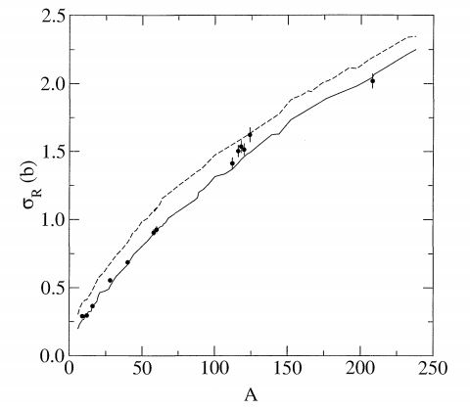

*Fig. 5.3:* Total reaction cross-section at 65.5MeV as the function of target mass.

Figure 5.3, proton total reaction cross-section data at 65.5MeV from a diverse set of nuclei are compared with predictions obtained using both the g and t - folding optical potentials. The total reaction cross-section shows the same behavior for proton projectile [24].

*Tab. 5.2:* The interaction cross section for different nucleus at 30, 60 and 200MeV energy

|  |  |  |  |  |
| --- | --- | --- | --- | --- |
|  |  | 30MeV | 60MeV | 200MeV |
| Nucleus | *RC* | *lo – fit* | *lo − fit* | *lo – fit* |
| 6*Li* | 9.27 | 3.727 | 4.063 | 1.526 |
| 12*C* | 7.44 | 4.988 | 6.019 | 6.195 |
| 19*F* | 6.35 | 6.069 | 7.665 | 8.915 |
| 40*Ca* | 4.65 | 7.086 | 10.199 | 12.848 |
| 89*Y* | 3.18 | 8.09 | 12.702 | 17.403 |
| 197*Au* | 2.17 | 10.749 | 15.077 | 23.425 |
| 208*Pb* | 2.06 | 10.989 | 15.115 | 23.606 |
| 238*U* | 2.91 | 11.65 | 15.888 | 25.195 |

The graph of the table 5.2 data is plotted on figure 5.4, 5.5 and 5.6 and also shows the same behavior with the figure 5.7 from ref[3]. Values of *lo* in Eq. (4.2), which reproduced experimental data (called direct *lo* fits in the following) for a given nucleus across energy, were studied. The direct *lo* fits, optimized for optimal smoothness with energy were found to be well behaved, smooth, and somehow linear, except for proton incident energies *E <* 50 MeV. So, good fits to data were possible then with just one parameter specified by interpolating the optimized values. However, if further functional properties of *lo* can be deduced, then, we may have a most simple to use method by which any required value of the reaction cross section might reasonably be predicted. The three graph shows the same behavior, when the parameter *lo* increases the nuclear radius decreases.

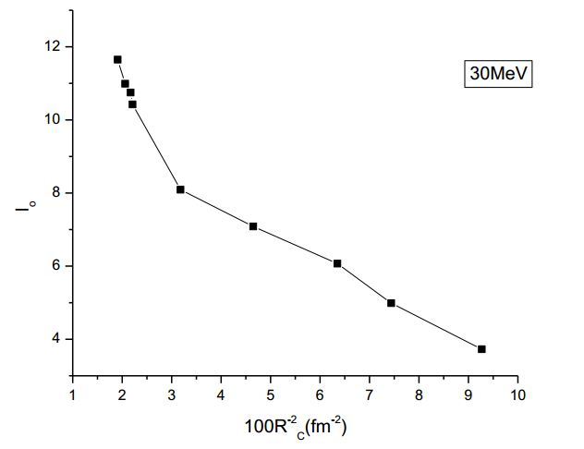

*Fig. 5.4:* Direct *lo*-fits for 30MeV energy

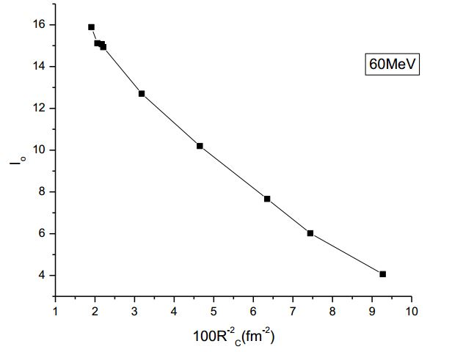

*Fig. 5.5:* Direct *lo*-fits for 60MeV energy

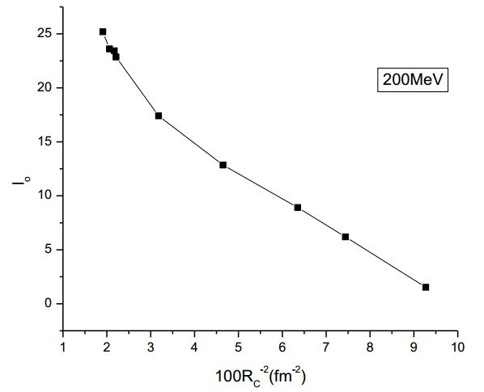

*Fig. 5.6:* Direct *lo*-fits for 200MeV energy

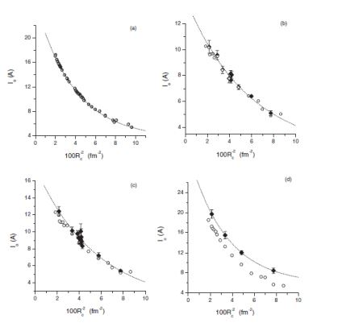

*Fig. 5.7:* Distinctions in direct *lo* fits (experimental data) are publicized by complete shapes, and the exposed circles display (a) exact *lo* fits to the g-folding potential calculations for 65 MeV protons, and (*b*) *and* (*d*) show enhanced *lo* fits to experimental data, with the inverse square of the nuclear-matter radius (*RC* ).

1. **Conclusion**

In nuclear physics reaction cross-sections are of major attention, since they offer a measurement of the size of the nucleus. Most importantly one can made total reaction cross-section measurements in a nuclear physics lab experiment. Systematic analyses of the total reaction cross-section for the proton incident on different nuclei target have been made for 65MeV energy. The difference seen at heavy nuclei amongst our parameterizations and experimental data (see from fig 5.1 and 5.2) is reasonable because in authors’ formulation they don’t take into account different physics effects related to: energy dependence of Coulomb barrier, projectile wave length and overlap volume (in deuteron case). Authors’ have seen also the interaction cross section on 6Li, 12C, 19F, 40Ca, 89Y, 184W, 197Au, 208Pb, and 238U nuclei at 30, 60 and 200MeV energy. The total reaction cross section calculation shows a good agreement with the experimental value.

**References**

[1] K. Amos and P. K. Deb, “Simple functional form for proton-nucleus total reaction cross sections,” Physical review C 66, 024604, 2002.

[2] F. K. Amanuel, B. Zelalem, A. K. Chaubey et al, “Role of break-up processes in the fusion of the 12C + 52Cr system” Physical review C 84, 024614, 2011.

[3] K. Matsushita, T. Nishio et al, “Measurement of proton-induced target fragmentation cross sections in carbon,” Nuclear Physics A 946 104–116, 2016.

[4]Akihisa Kohama, Kei Iida, and Kazuhiro Oyamatsu, “Energy and Mass-Number Dependence of Hadron-Nucleus Total Reaction Cross Sections,” Journal of the Physical Society of Japan, 2016.

[5] Badawy Abu-Ibrahim and Akihisa Kohama, “Scaling properties of proton-nucleus total reaction cross sections,” 2017.

[6] Kenneth S. Krane, “Introductory Nuclear Physics,” John Wlley & Sons, ISBN 0-471 -80553-X, 1988.

[7] A. de Vismes, P. Roussel-Chomaz et al., “Proton reaction cross-section measurements on stable and neutron- rich nuclei as a probe of the nucleon–nucleus interaction,” Nuclear Physics, A 706, 2002.

[8] B. A. Zelalem, F. K. Amanuel, and A. K. Chaubey., “30–300 MeV proton-nucleus total reaction cross sections,” Phys. Rev. C 84, 044606, 2011.

[9] C.M. Werneth, X. Xu, R.B. Norman, W.P. Ford, K.M. Maung, “Validation of elastic cross section models for space radiation applications,” Nuclear Instruments and Methods in Physics Research B 392, 74–93, 2017.

# [10] G. Ber tsch and Philip J. Siemens, “Nuclear fragmentation,” Phys. Lett. 126B, No. 1 and 2, 1984.

##### [11] S. Kox, A. Gamp, C. Perrin et al., “Trends of total reaction cross sections for heavy ion collision in an intermediate energy range,” Phys. Rev. C 35, 1678, 1987.

[12] Ozawa A, Suzuki T and Tanihata I “Nuclear size and related topics,” Nucl. Phys. A 693 32, 2001.

# [13] A. J. Koning and J. P. Delaroche, “Local and global nucleon optical models from 1 keV to 200 MeV,” Nucl. Phys. A 713, 231, 2003.

##### [14] A. Auce, Ingemarsson, R. Johansson et al.,” Reaction cross sections for protons on 12C,40Ca,90Zr, and 208Pb at energies between 80 and 180 MeV,” Phys. Rev. C 71, 064606, 2005.

##### [15] P. Mer mod, Blomgren, C. Johansson et al., “95 MeV neutron scattering on hydrogen, deuterium, carbon, and oxygen,” Phys. Rev. C74, 054002, 2006.

### [16] Wellisch H P and Axen D, “Total reaction cross section calculations in proton-nucleus scattering,”Phys. Rev. C 541329, 1996.

### [17] Ingemarsson A. and Lantz M., “Geometrical aspects of reaction cross sections for 3He, 4He, and 12C projectiles,” Phys. Rev. C 67 064605, 2003.

## [18] R.F. Carlson, “Proton-Nucleus Total Reaction Cross Sections and Total Cross Sections Up to 1 GeV,” At Data Nucl. Data Tables 63, 93, 1996.

### [19] S.Majumdar, P. K. Deb, and K. Amos, “A simple functional form for total reaction cross sections for protons scattering from 12C and from 208Pb,” Phys. Rev. C 64, 027603, 2001.

### [20] P. K. Deb and K. Amos, “Predicting proton-nucleus total reaction cross sections up to 300 MeV using a simple functional form,” Phys. Rev. C 67, 067602, 2003.

### [21] P. K. Deb and K. Amos, “Simple function forms and nucleon-nucleus total cross sections,” Phys. Rev. C 69, 064608, 2004.

[22] A. Nathanael, E. Schmidt, W. Wesch, E. Wendler, “Indirect method to measure differential cross-sections for nuclear reaction analysis,” Nuclear Instruments and Methods in Physics Research B 345, 2015.

[23] K. Amos, S. Karataglidis and P. K. Deb, “Predictions of total and total reaction cross sections for nucleon-nucleus scattering up to 300 MeV,” Phys. Rev. C 65, 064618, 2002.

[24] P. K. Deb, K. Amos, S. Karataglidis, M. B. Chadwick, and D.G. Madland, “Predicting total reaction cross sections for nucleon-nucleus scattering,” 2001.

[25] Rong Xu, Dong-Hai Zhang, “Two and three particle correlations in target fragmentation at  
relativistic nucleus–nucleus collisions,” Chinese Journal of Physics, *pages 724–733, 2016.*

[26] Chun-Tian Liang, Yan-An Luo, Xiao-Hua Li and Chong-Hai Cai, “Systematic analysis of the reaction cross section for *d*, 3He and 4He as projectiles,” Journal of physics g: nuclear and particle physics, 2009.

[27] Tapan Mukhopadhyay, Joydev Lahiri, and D. N. Basu, “Cross sections of neutron-induced reactions,” Physical review C 82, 044613, 2010.

[28]Akihisa Kohama, Kei Iida and Kazuhiro Oyamatsu, “Reaction cross section described by a black sphere approximation of nuclei” Physical review C 72, 024602, 2005.